Larsen Architecture to Host New Business-Focused Programme at Design Central’s 10th Anniversary
April 9, 2026

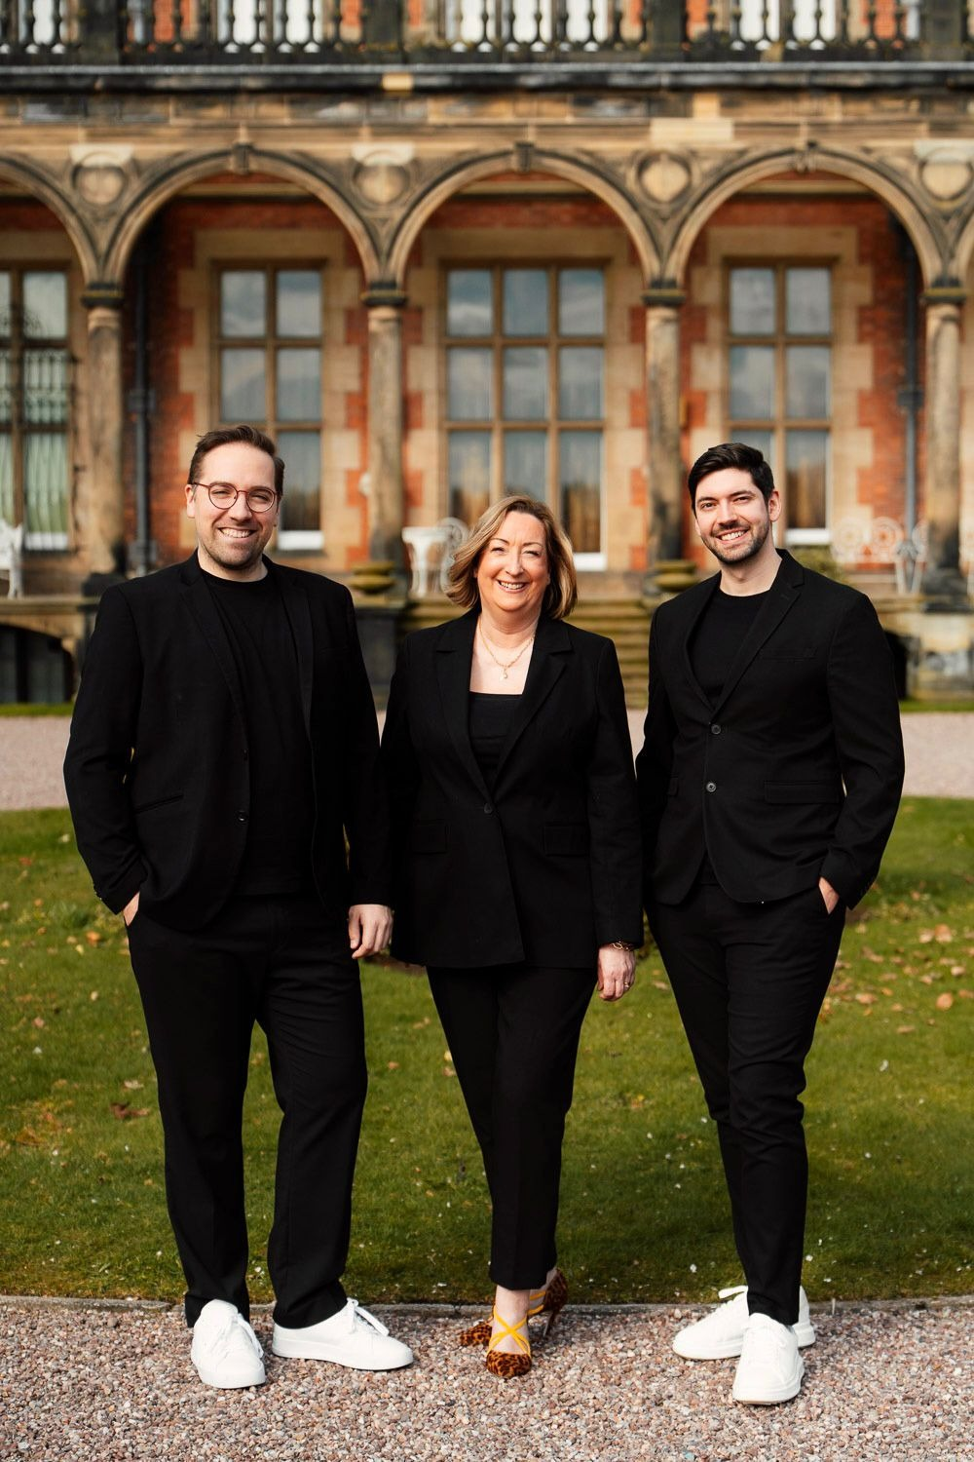
Image credit: Larsen Architecture

Bridging architecture, interiors and commercial intelligence at one of the UK’s largest regional design events.
Ryan Wenham and Marc Prats of Larsen Architecture have been confirmed as strategic partners for Design Central 2026, taking place this September at the remarkable Capesthorne Hall in Cheshire.
Marking its tenth anniversary, Design Centralis the largest trade show of its kind outside London, welcoming designers from throughout the UK across two days. This year, the event introduces a new dimension: structured business insight for creative professionals.
As a practising architect and interior designer, Wenham brings first-hand understanding of the commercial pressures facing studios today. Alongside him, organisational psychologist Prats introduces a discipline rarely seen within the design sector; applying behavioural science and leadership frameworks to creative businesses. Together, they will deliver an interactive stage experience throughout the event, intended to move designers beyond inspiration and into strategic growth.
Wenham said: “Design talent deserves commercial strength. Too many creative studios operate without the leadership frameworks that allow them to scale confidently. We want designers to leave with practical tools, not just ideas.”
Prats added: “Creative businesses are still businesses in the traditional sense. Understanding how teams think, make decisions and grow sustainably is not optional, it is essential.”
In addition to their on-stage presence, Wenham and Prats will be interviewing selected exhibitors ahead of the event, highlighting the importance of meaningful collaboration between designers and trade suppliers.
Journalists are invited to contact Danielle Windecker-Hilton to arrange interviews with Ryan Wenham and Marc Prats or Design Central's Cath McCubbin.

Source: News By Wire
URL: https://newsbywire.com/larsen-architecture-to-host-new-business-focused-programme-at-design-centrals-10th-anniversary/
Media Contact
Name: Danielle Windecker-Hilton
Organisation: Sycamore Communications
Email: danielle@sycamorecommunications.co.uk
Telephone: +447704763269

